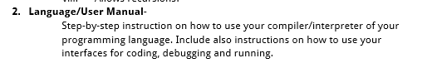

**<NAME OF PROGRAMMING LANGUAGE>**

**CS 150 Machine Problem**

User Manual

**Gueco, Maria Rosario**

**Juntado, Marbille**

**Lenon, Mikaela Jun**

**Navarro, Gabriel Kelly**

**Arceo, Jahziel Rae**

**CS 150 HTWX**